1989 D
The carbon isotope of mass 12 is stable. The carbon isotopes of mass 11 and mass 14 are unstable. However, the type of radioactivity decay is different for these two isotopes. Carbon-12 is not produced in either case.
(a) Identify a type of decay expected for carbon-11 and write the balanced nuclear reaction for that decay process.
(b) Identify the type of decay expected for carbon-14 and write the balanced nuclear reaction for that decay process.
(c) Gamma rays are observed during the radioactive decay of carbon-11. Why is it unnecessary to include the gamma rays in the radioactive decay equation of (a)?
(d) Explain how the amount of carbon-14 in a piece of wood can be used to determine when the tree died.
Answer:
(a) Positron decay: 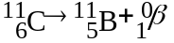
OR
Electron capture: 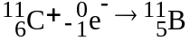
(b) Beta decay: 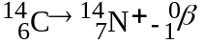
(c) Gamma rays have no mass or charge (or they are energy) so they need not be shown in nuclear equations.
(d) Measure the amount of C-14 in the dead wood. Compare with the amount of C-14 in a similar living object.

1991 D
Explain each of the following in terms of nuclear models.
(a) The mass of an atom of ⁴He is less than the sum of the masses of 2 protons, 2 neutrons, and 2 electrons.
(b) Alpha radiation penetrates a much shorter distance into a piece of material than does beta radiation of the same energy.
(c) Products from a nuclear fission of a uranium atom such as ⁹⁰Sr and ¹³⁷Ce are highly radioactive and decay by emission of beta particles.
(d) Nuclear fusion requires large amounts of energy and to get started, whereas nuclear fission can occur spontaneously, although both processes release energy.
Answer:
(a) When nucleons are combined in nuclei, some of their mass (mass defect) is converted into energy (binding energy) which is released and stabilizes the nucleus.
(b) Alpha particles have a greater mass than beta particles. Thus, their speed (penetrating potential) is less.
(c) The neutron/proton ratio in Sr-90 and Cs-137 is too large and they emit beta particles (converting neutrons into protons) to lower this ratio.
(d) Large amounts of energy are needed to initiate fusion reactions in order to overcome the repulsive forces between the positively charged nuclei. Large amounts of energy are not required to cause large unstable nuclei to split apart.

1997 D
Answer each of the following questions regarding radioactivity.
(a) Write the nuclear equation for decay of ²³⁴₉₄Pu by alpha emission.
(b) Account for the fact that the total mass of the products of the reaction in part (a) is slightly less than that of the original a(234, 94)Pu.
(c) Describe how α, β, and γ rays each behave when they pass through an electric field. Use the diagram below to illustrate your answer.
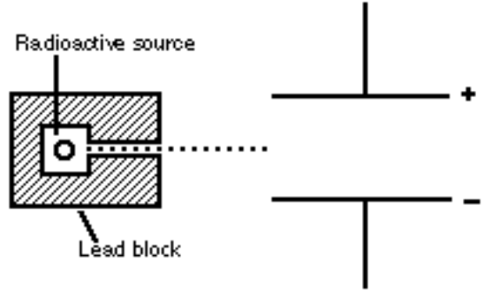
(d) Why is it not possible to eliminate the hazard of nuclear waste by the process of incineration?
Answer:
(a) ²³⁴₉₄Pu → ⁴₂α + ²³⁰₉₂U
Due to a printing error, the student’s answer booklet had the Pu-239 isotope. Therefore, the following is a valid response.
²³⁹₉₄Pu → ⁴₂α + ²³⁵₉₂U
(b) This mass defect has been converted into energy. ΔE = Δmc²
(c) An alpha particle, α or He nuclei, has a 2+ charge and would be attracted to the (-) side of the electric field. A beta particle, β, or electron, has a single negative charge and is attracted to the positive side of the electric field, but since it is much lighter and faster than an alpha it would not be as strongly deflected. Gamma, γ, rays are not charged and, therefore, not deflected by the electric field.
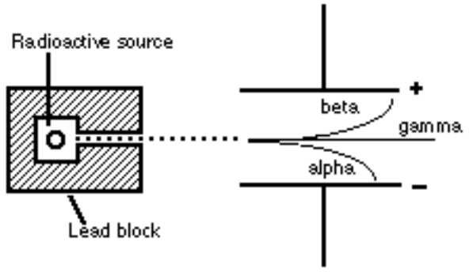
(d) The half-life of a radionuclide is independent of its environment. Incineration will neither accelerate its decay nor render it non-radioactive. Half-life is a function of its nucleus, incineration is a function of its electrons.

